Assignment #2 – Question #2: Graphs printout

Suppose that we wish to calculate $\int_{1}^{9}{\log_{2}\left(x\right)dx}$. Answer the following questions:

1. Draw the exact desired integral on the diagram below (graphically – no calculations).

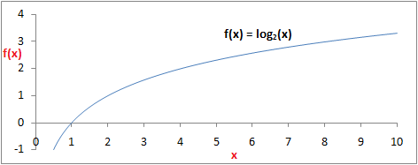

1. What is the approximation for the integral using one trapezoid (based on the trapezoid rule)? Show the trapezoid on the diagram below. Show your calculations and result in the Excel workbook **A2Q2Calculations.xlsx** in the **1Trap** worksheet.



1. What is the approximation for the integral using two trapezoids (based on the trapezoid rule)? Show the trapezoids on the diagram below. Show your calculations and result in the Excel workbook **A2Q2Calculations.xlsx** in the **2Trap** worksheet.



1. What is the approximation for the integral using four trapezoids (based on the trapezoid rule)? Show the trapezoids on the diagram below. Show your calculations and result in the Excel workbook **A2Q2Calculations.xlsx** in the **4Trap** worksheet.



1. What is the approximation for the integral using eight *rectangles* (based on the **left rectangle rule**)? Show the rectangles on the diagram below. Show your calculations and result in the Excel workbook **A2Q2Calculations.xlsx** in the **8Rect** worksheet.



1. In the **Summary** worksheet in the Excel workbook **A2Q2Calculations.xlsx**, calculate the amount of error in each approximation from (b) to (e) by comparing each approximation to the correct result (the calculated value from Question #1(c) or another source like Wolfram|Alpha). Express the error as an absolute amount and also as a percentage. (See the comments in cells B4:D4 for details.) Based on those results, fill in cell B12 with the answer to the question in cell A11.
2. Write your name(s) and SaskPolytech username(s) below: